Vele Tosevski

1002174657

CSC 411

March 27, 2019

**HW6 Write-Up**

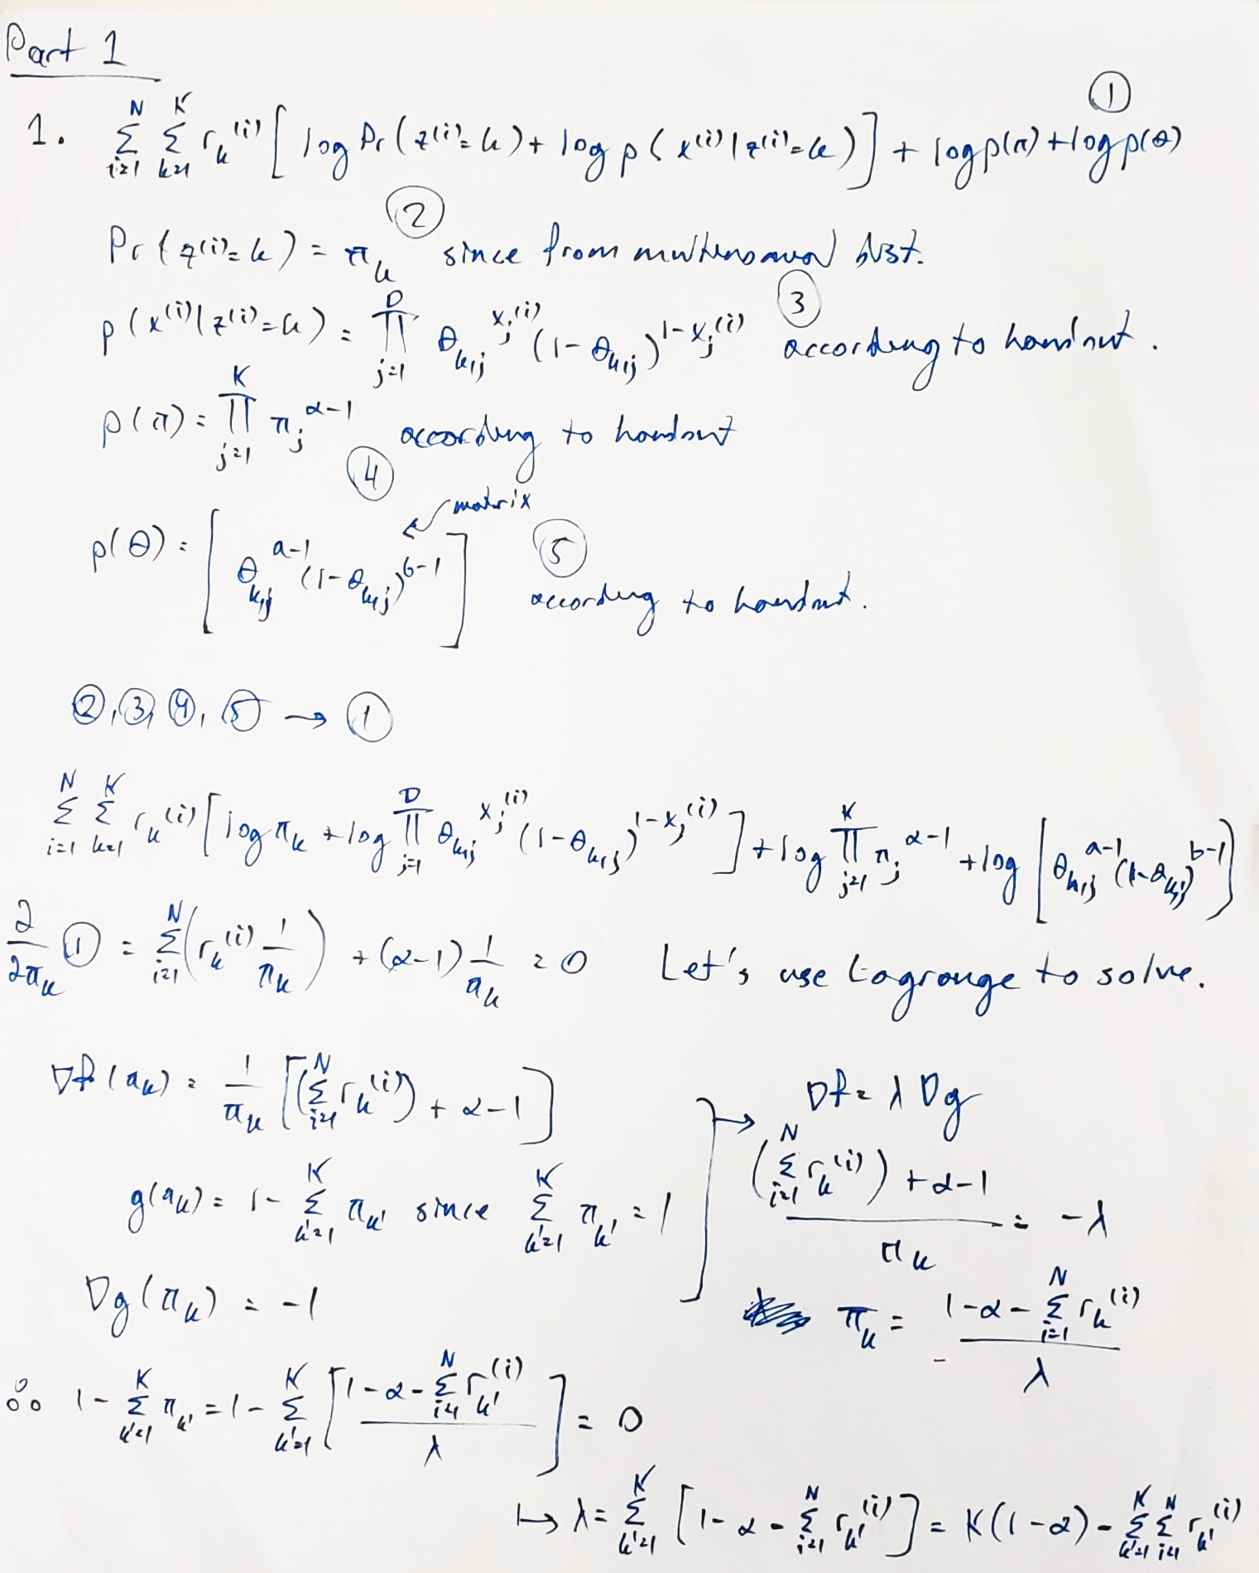

****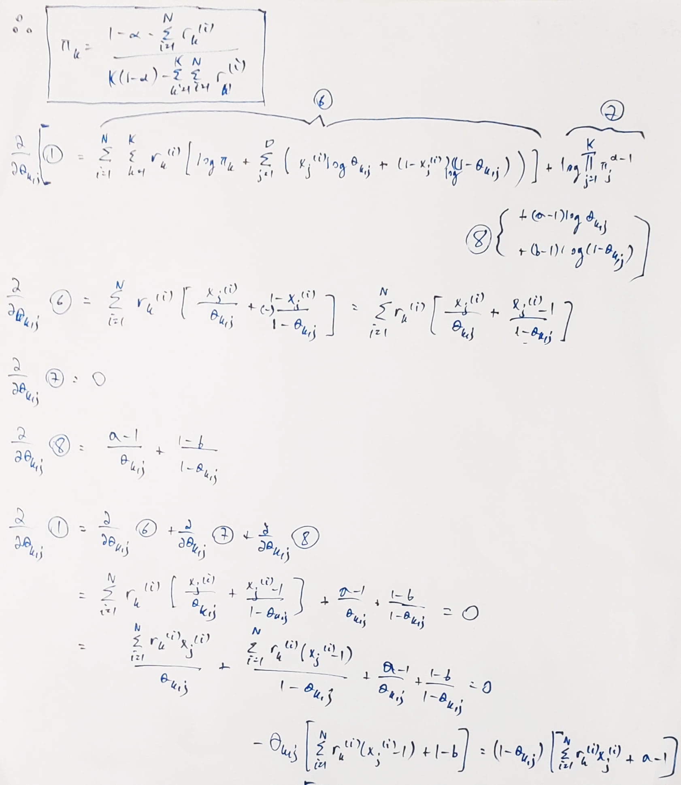



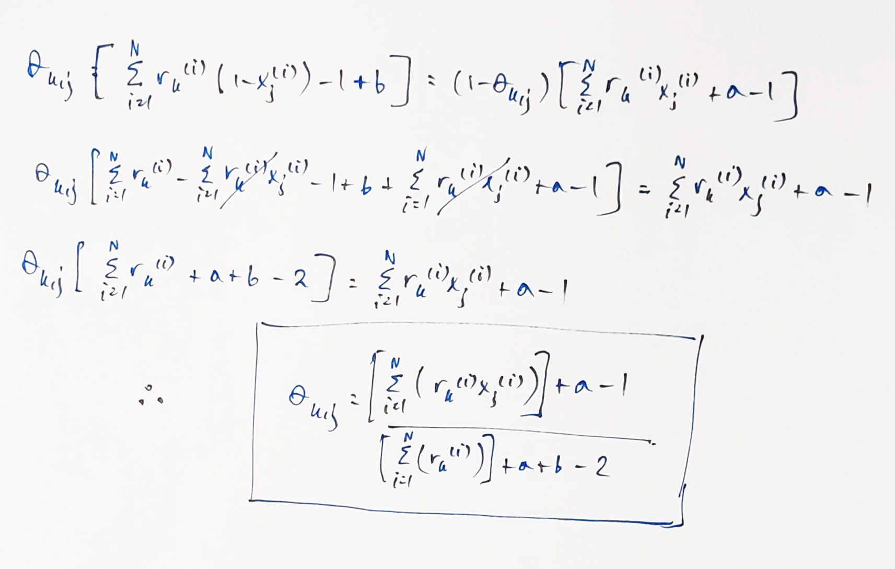

2.

Code in mixture.py

Part 1 output →

pi[0] 0.085

pi[1] 0.13

theta[0, 239] 0.6427106227106232

theta[3, 298] 0.46573612495845823

The theta update seems OK.

The pi update seems OK.

